**G80级起重欧标强力子母环**

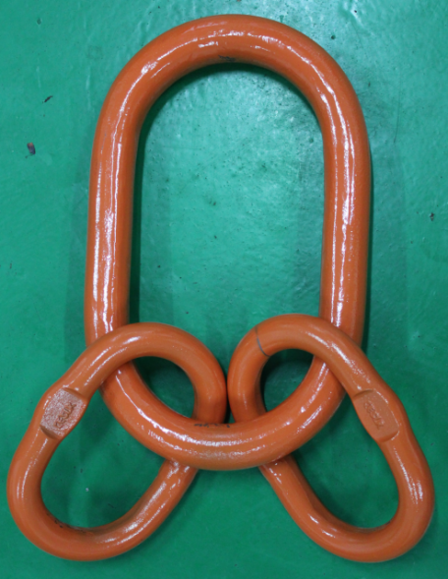

|  |  |  |  |  |  |  |  |  |  |
| --- | --- | --- | --- | --- | --- | --- | --- | --- | --- |
| **G80级起重子母环（G81 MASTER LINK ASSEMBLY)** | | | | | | | | | |
| **PL01-G80 EUROPEAN TYPE G80 MASTER LINK ASSEMBLY G80级欧标强力子母环** | | | | | | | | | |
| ITEM CODE 货号 | G80 EN818-2 CHAIN 配合80级链条直径MM | WEIGHT (KG) 单重 | WLL(T) 工作拉力 | DIMENSION(MM)尺寸 | | | | | |
| FOR 3 OR4 LEG SLING 3腿或4腿链条吊具 | A | B | D | a | b | d |
| PL01-6 | 6 | 1.18 | 2.36 | 135 | 75 | 18 | 54 | 25 | 13 |
| PL01-7 | 7 | 1.24 | 3.15 | 135 | 75 | 18 | 60 | 34 | 13 |
| PL01-8 | 8 | 2.2 | 4.25 | 160 | 90 | 22 | 70 | 38 | 16 |
| PL01-10 | 10 | 3.4 | 6.7 | 180 | 100 | 26 | 85 | 40 | 18 |
| PL01-13 | 13 | 6.1 | 11.2 | 200 | 110 | 32 | 115 | 50 | 22 |
| PL01-16 | 16 | 9.98 | 17 | 260 | 140 | 36 | 140 | 65 | 26 |
| PL01-18 | 18 | 18.9 | 21.2 | 340 | 180 | 45 | 180 | 100 | 32 |
| PL01-20 | 20 | 22.6 | 26.5 | 350 | 190 | 50 | 180 | 100 | 32 |
| PL01-22 | 22 | 25.2 | 31.5 | 350 | 190 | 50 | 180 | 100 | 36 |
| PL01-26 | 26 | 35.2 | 45 | 400 | 200 | 56 | 180 | 100 | 40 |
| PL01-28 | 28 | 47 | 50 | 430 | 220 | 63 | 180 | 100 | 45 |
| PL01-32 | 32 | 66.46 | 63 | 460 | 250 | 72 | 200 | 110 | 50 |

|  |
| --- |
| 破断拉力是工作拉力的4倍。 |
| 工作拉力是基于3腿或4腿吊装时，吊装角度为0度到45度。 |
| **警告：绝对不能超过工作拉力使用** |